COS108: Web Programming and Applications



Htet Arkar Lwin

[00608]

[BUC-HDIT]

July 26, 2022

Table of Contents

**Introduction** 2

**Task 1 – Web Design** 2

**Task2 – Database Connectivity** 7

**Conclusion** 12

References 13

# **Introduction**

This report is all about the web pages that created for TMC tennis club. And explanation details about the coding for this web pages and design about that web pages.

# **Task 1 – Web Design**

This website is convenient to use for the student and admin to know about the information of the tennis matches’ timetable and can control about the member registration for admins.

This part is all about HTML coding and design with photos.

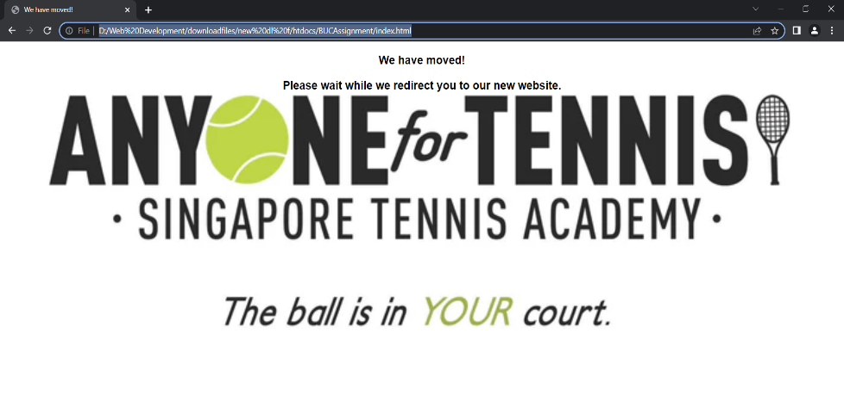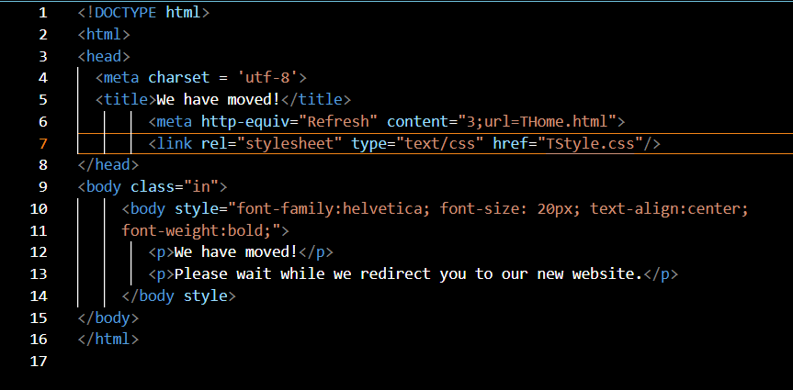For Index.html, “Refresh” function and linked with “THome.html”. Using of “Refresh” function is to get the home site just in a moment as shown in the “Index.photo”. And using “TStyle.css” is to change the style that show up in website. And all webpages link with “TStyle.css”.

Index.photo

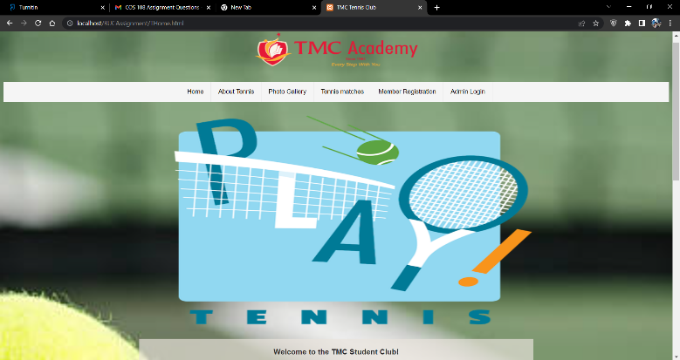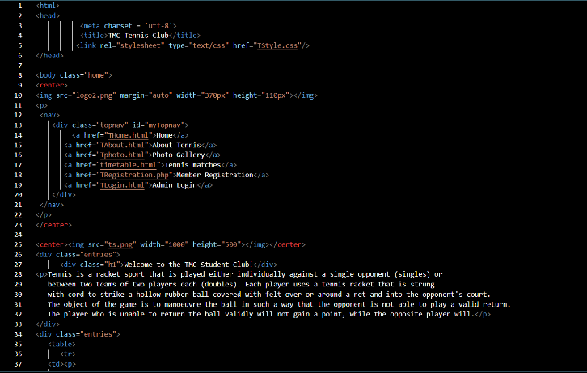 Home.html is about the general about how to play tennis and it links to the other pages for students who like to know about other information including registration. In the first part of the body, links with other pages in the purpose of to get a wonderful webpage like in “Home page 1”.

Home page 1 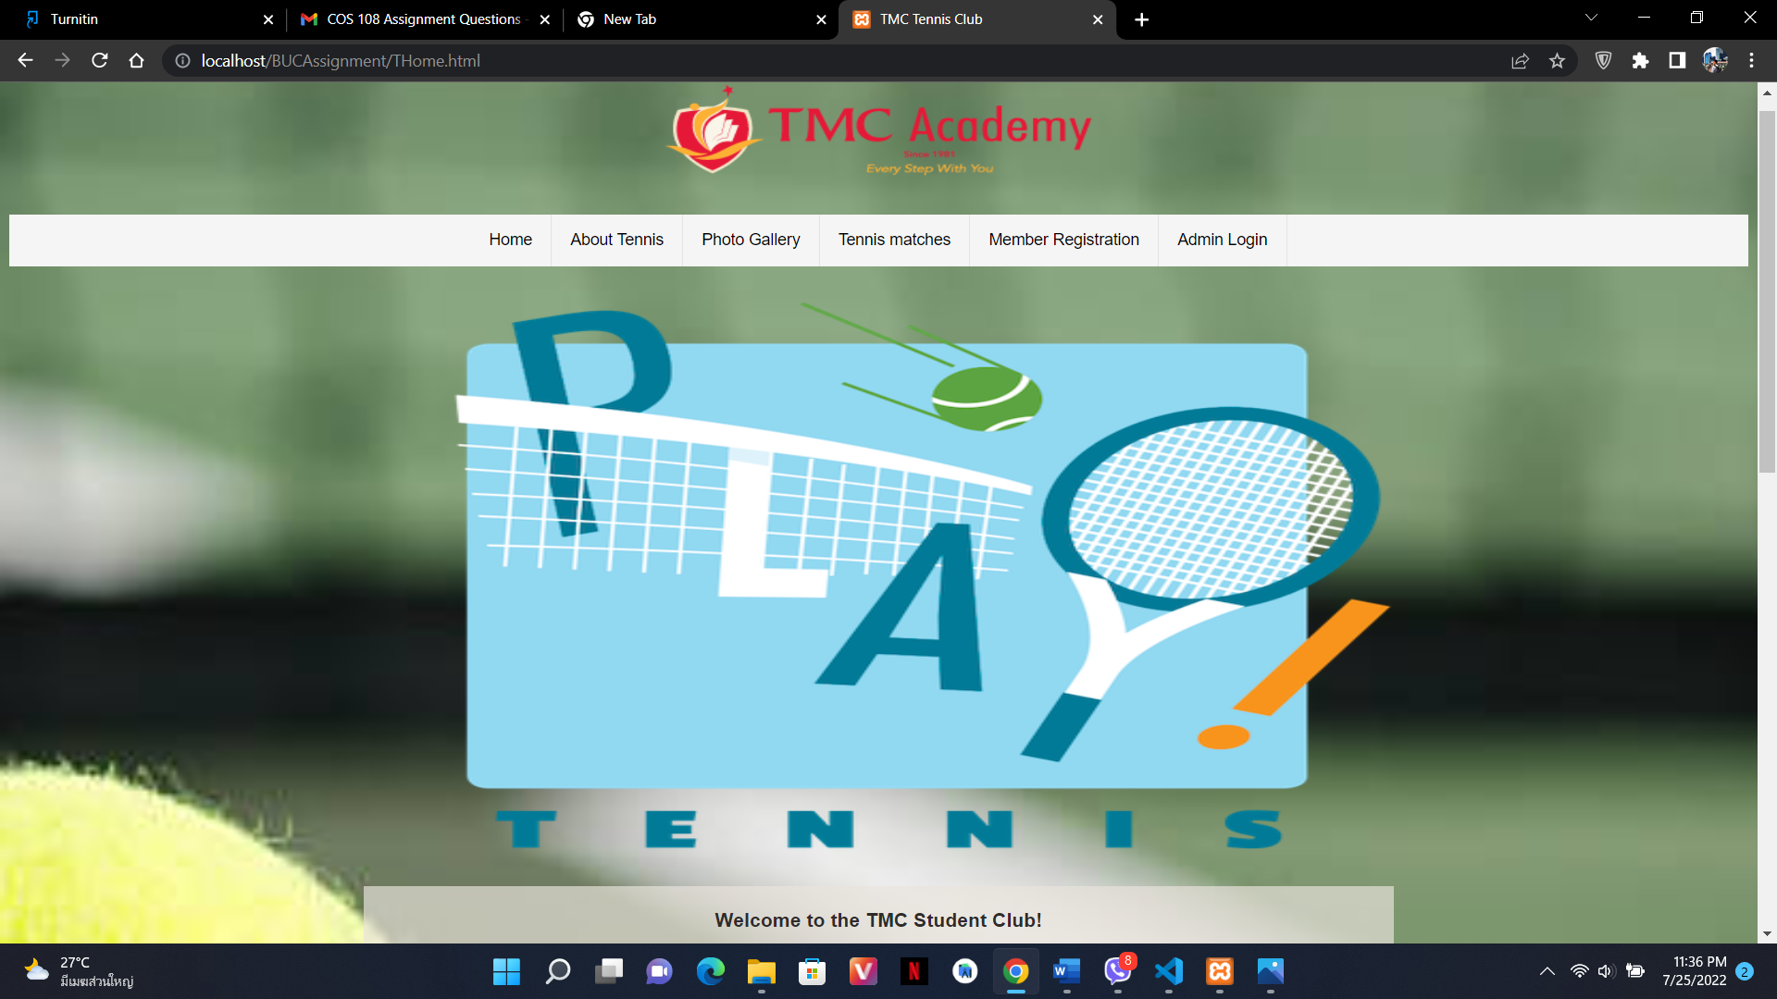.photo

Coding about home page 1

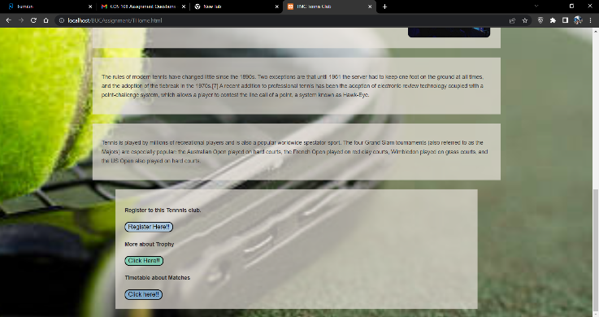Links to the other pages are like in the “Home page 2”.

Home page2.photo

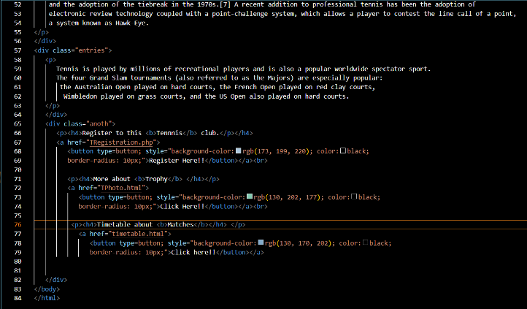

Coding about home page 1

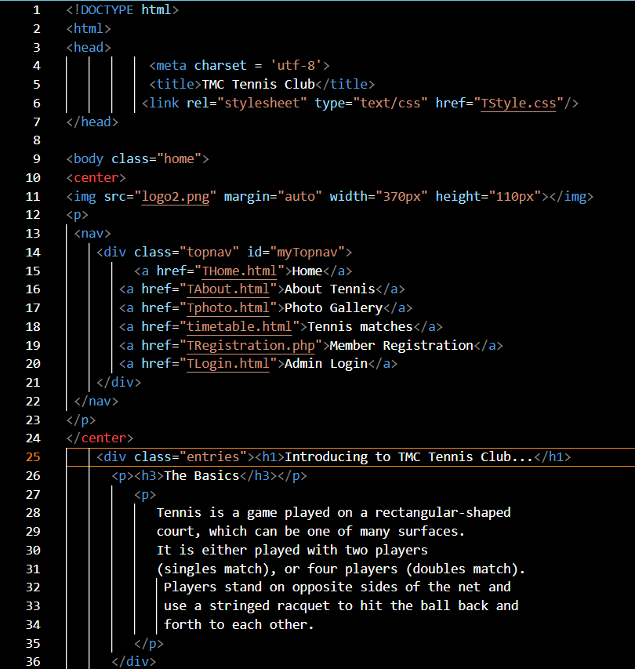

In about.html page, it explains about the tennis rules and regulations. And this page also links with other pages. This is because of more convenient for the users.

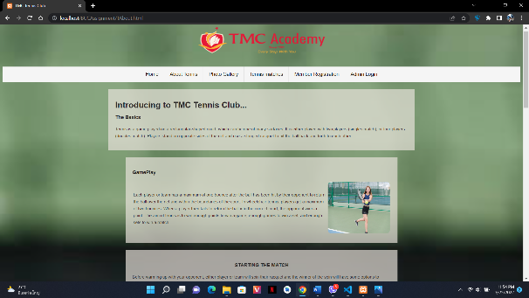

About page.photo

Coding for about page

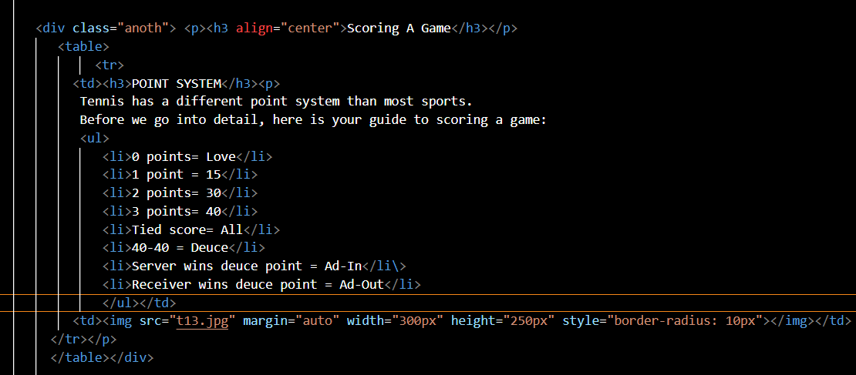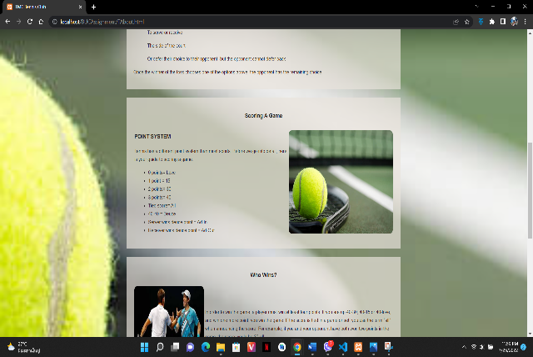In the middle of this code, there is a list about the tennis’s point system with the “<ul>”and “<li>” in the code for the users to know exactly about the details about the point system.

Coding for about2.html

About page 2 .photo

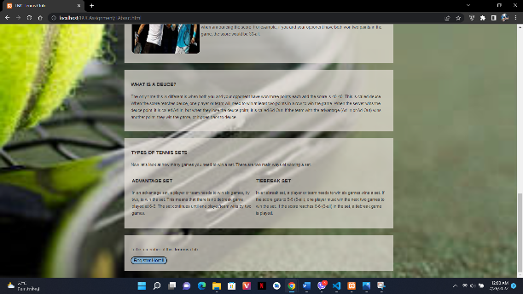 Then, in the end of this page there is a register link to get the registration. In the coding, it also links with “Registration.php”.

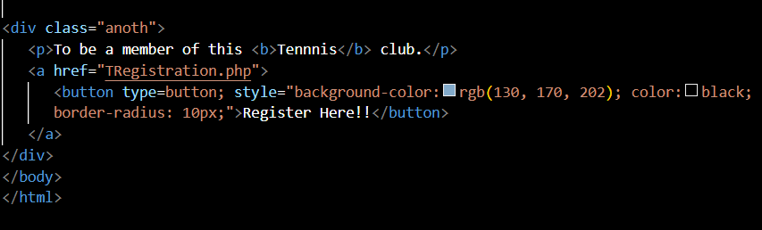

About page 3 .photo

Coding for about 3.html

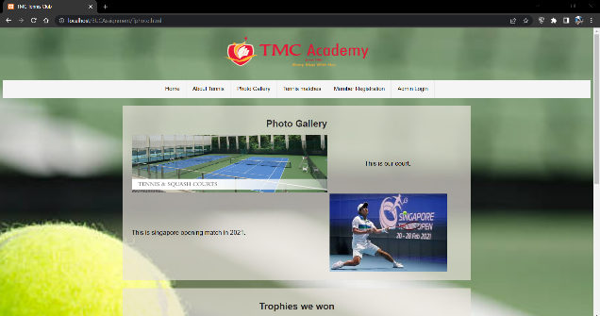In the photo gallery, described about the court and the trophies won. In this coding, inserted photos with tables.

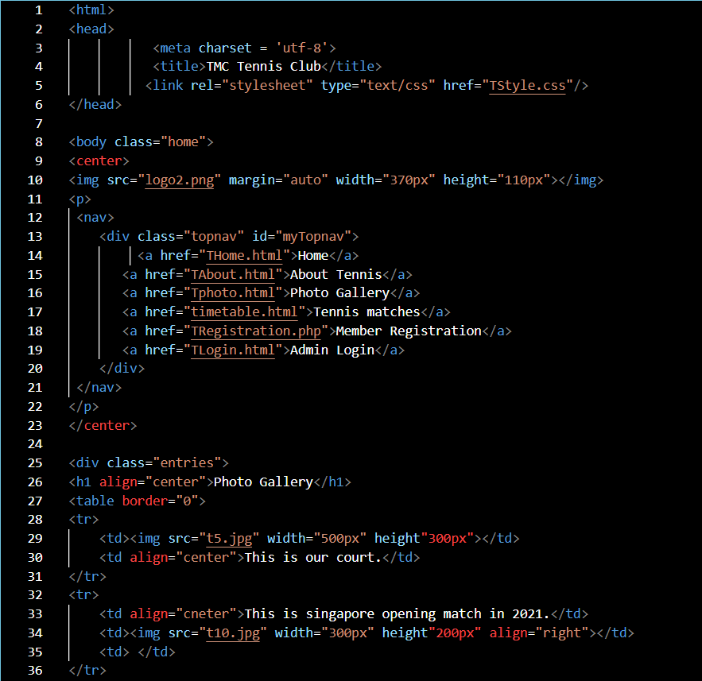

Photo Gallery .photo

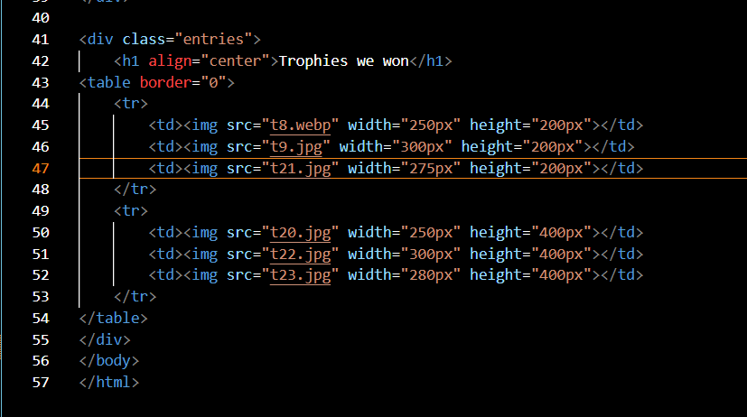

Coding for photo gallery

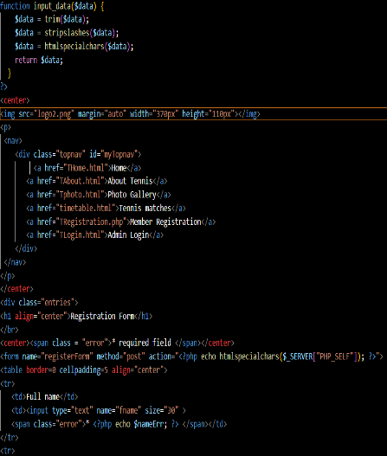 For registration.php, it links with database to save the data of member and uses php validation for correct format of data. If the data is correct, users can submit that form easily but if the data that is added by users isn’t correct, it will show up as shown in the “Registration2.photo”. And the form taps make that registration form to format.

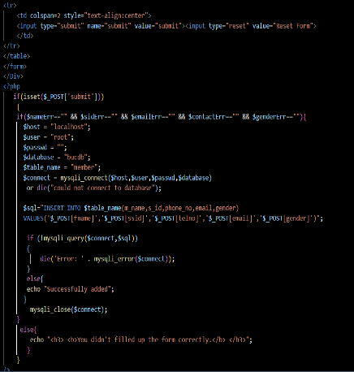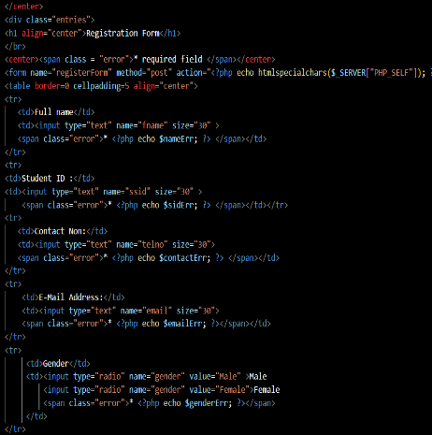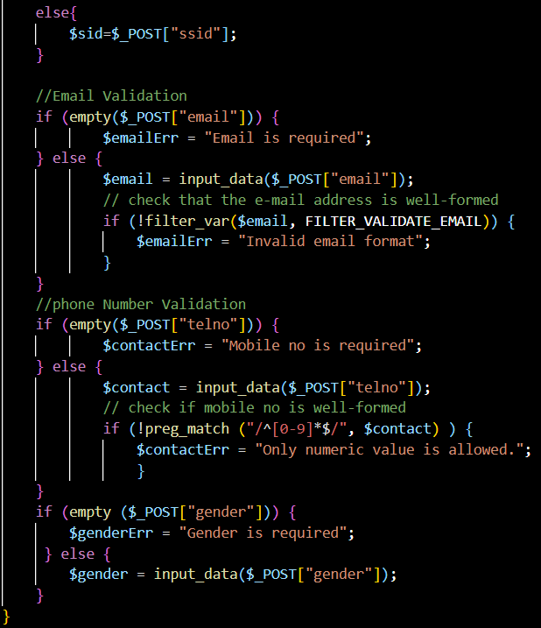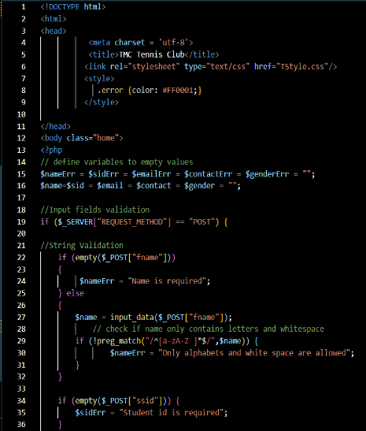

Coding for Registration.php

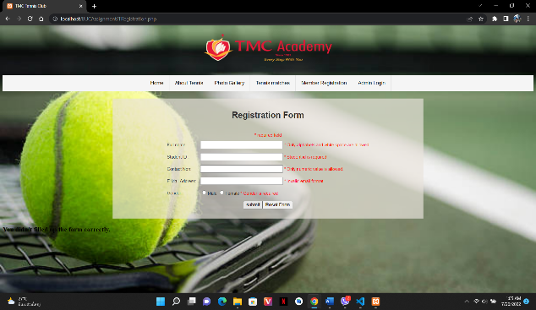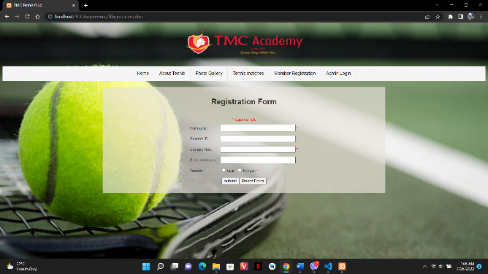

Registration page 1.photo

Registration page 2 .photo

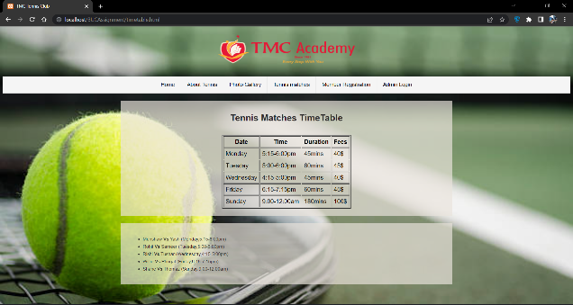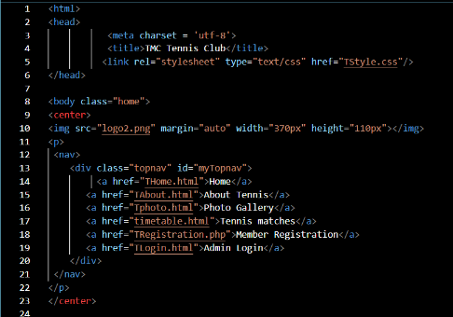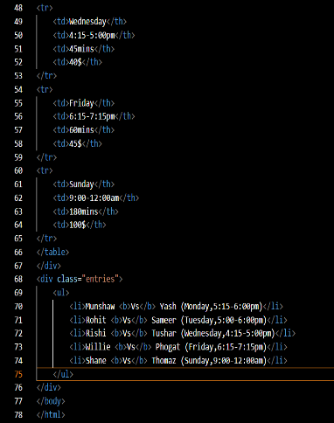 In timetable page, there is a matches table. And about the starting time and duration of the matches. Then there is also of the list of players.

Timetable page .photo

Coding for timetable. html

# **Task2 – Database Connectivity**

This task 2 is about database connectivity about the member registration. It’s included login, welcome, add data, view data, edit data and delete data.

In admin login page, it is a simple page but sign in is not included in this login page. And links to “Log_in.php”. There is required for correct username and password in the coding. And it is a “submit” type and there is two button “Login” and “Clear” within the “Form” function.

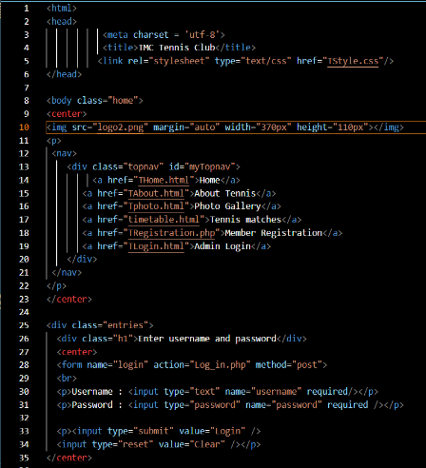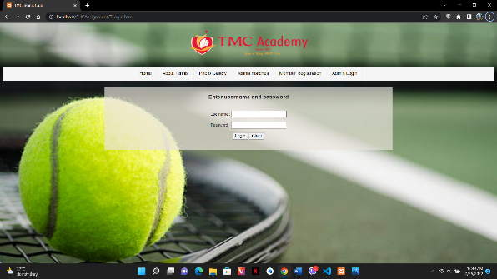

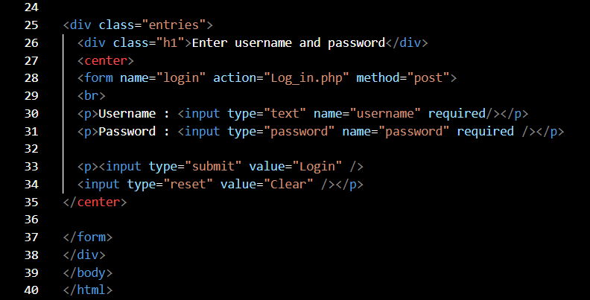

Coding for login page

Login page.photo

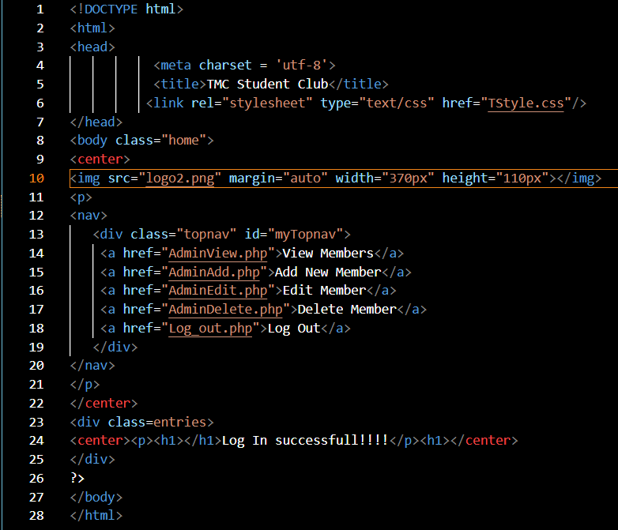For welcome.html, this page will appear when login successfully from admin login. And this page is the start of the admin side.

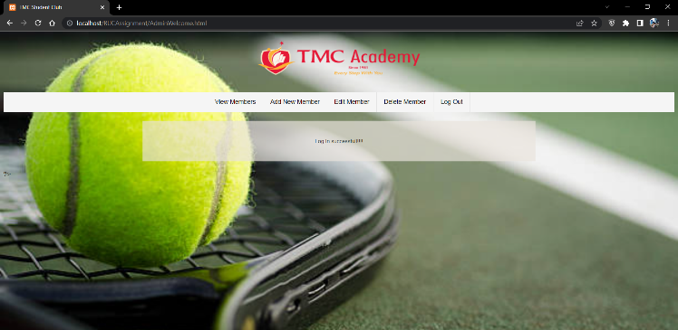

Welcome Page.photo

Coding for welcome page

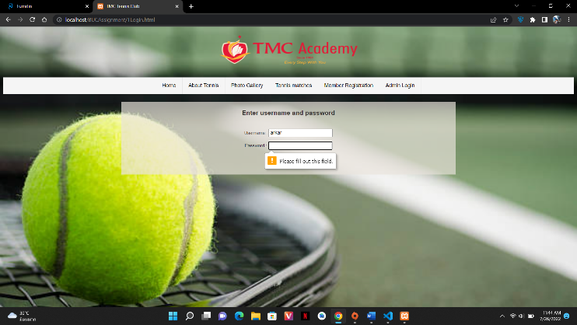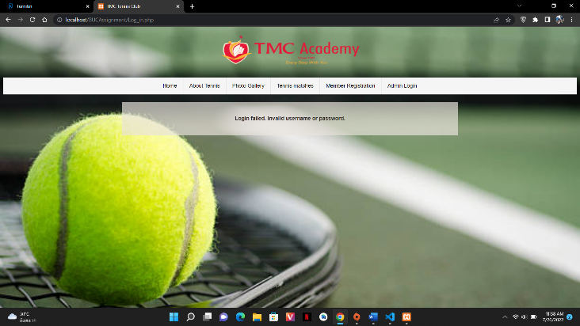 If users don’t fill up the correct username or password, it will show up that login is failed. Like in “welcome page 1”.

Welcome page 1 .photo

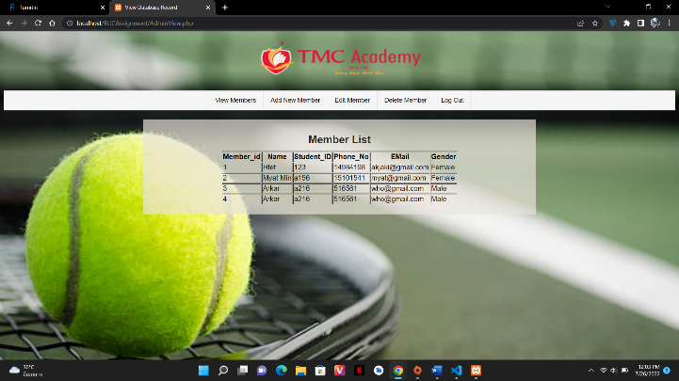 In “View Members” page there is a table about member details as shown in “view page”. If the admin wants to add more new members, it can be added by “Add New Member” page. And if some data is wrong, it can be edited by “Edit Member” page. Then if admin wants to delete member, it can be done by “Delete Member” page. Want to logout form this admin view, just need to touch that logout button on the right top of the page.

View page

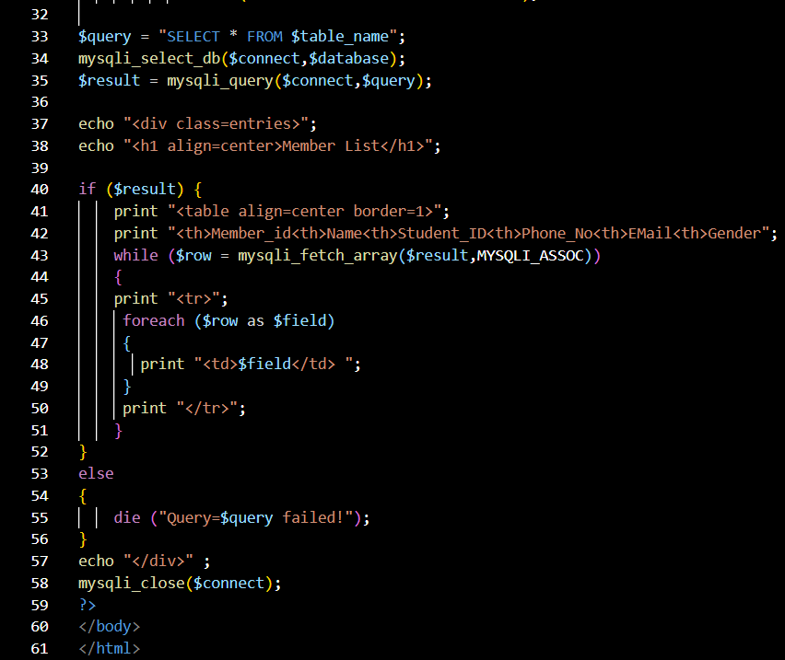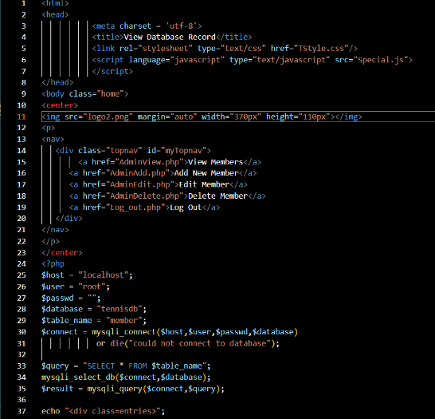

Coding for view page

Add page

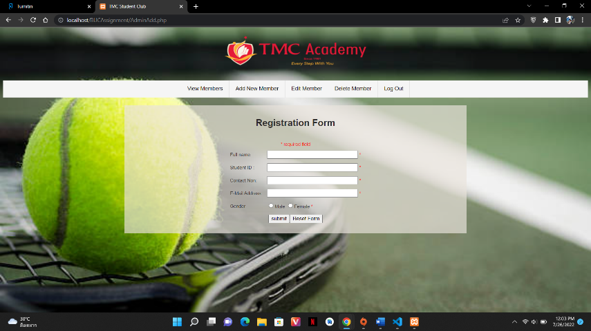

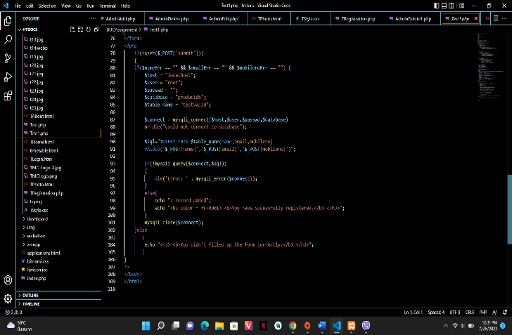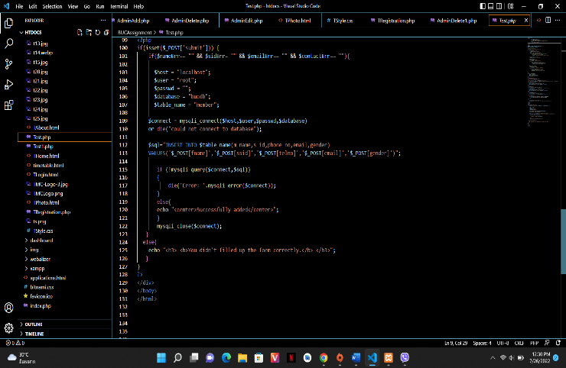 In this add new member page and it is similar to the “register” page. And it is also link with “registration.php”. If don’t fill the correct form, it will show up to fill the form correctly.

Coding for add page

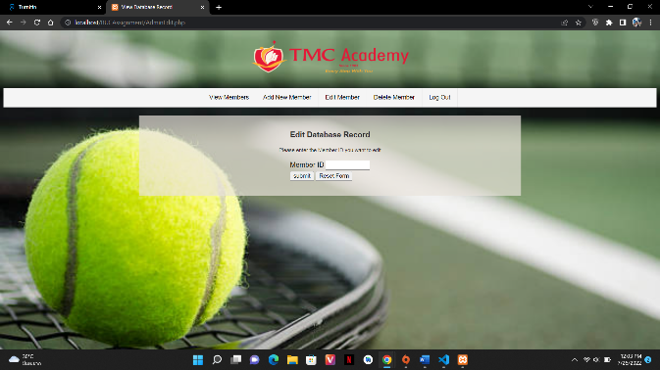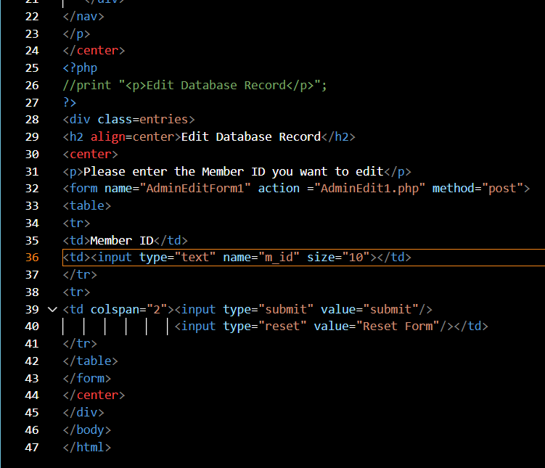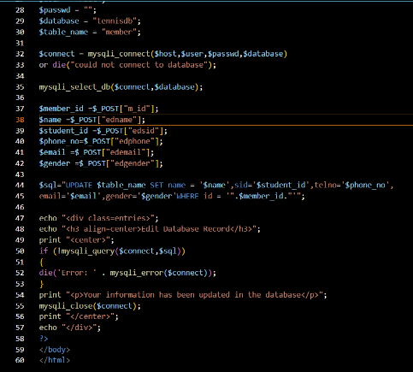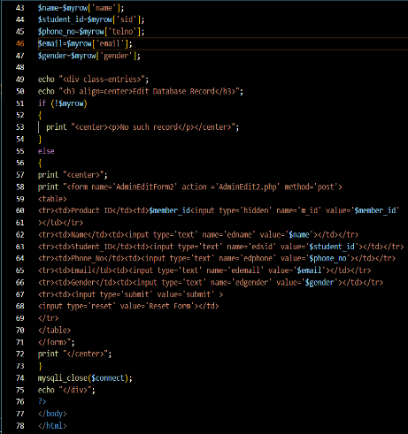 In this edit page, there are 3 coding for this. Edit 1.php and edit 2.php are link with database. This is because of the edit the data from the database. And this coding use validation for the correct data form. If input the data that isn’t locate in the database it will show up to input the correct answer.

Edit page

Coding for edit.php

Coding for edit2.php

Coding for edit1.php

In this delete page, there are delete.php and delete1.php. But delete1.php links to database. In the purpose to delete the data form database. Delete page is similar to the edit page, it is only need to input the ID that need to edit.

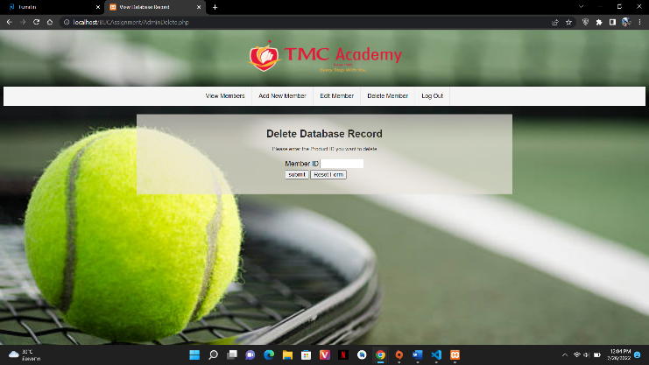

Delete page

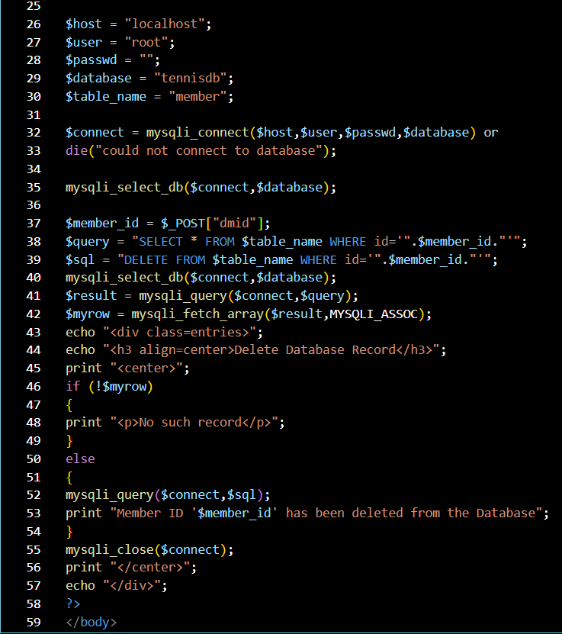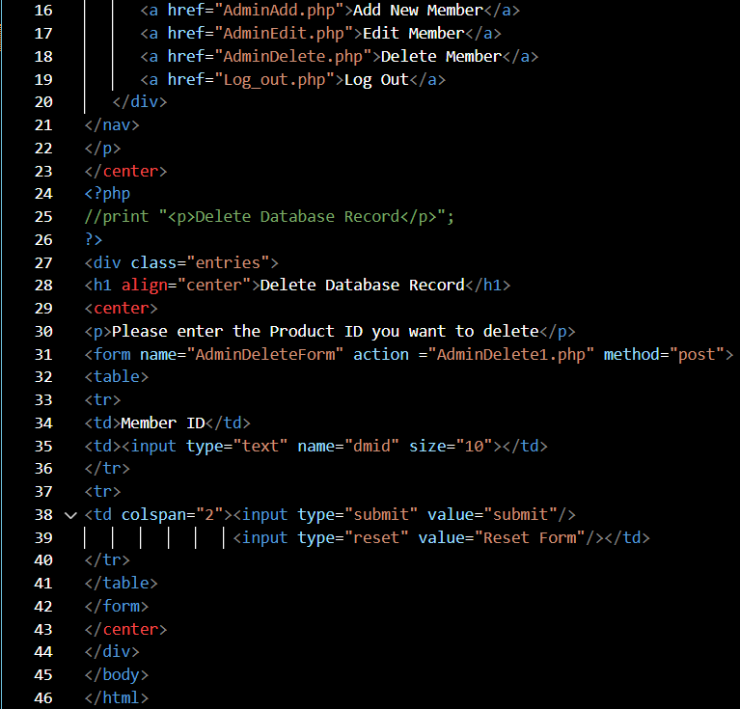

Coding for delete page

Coding for delete1.php

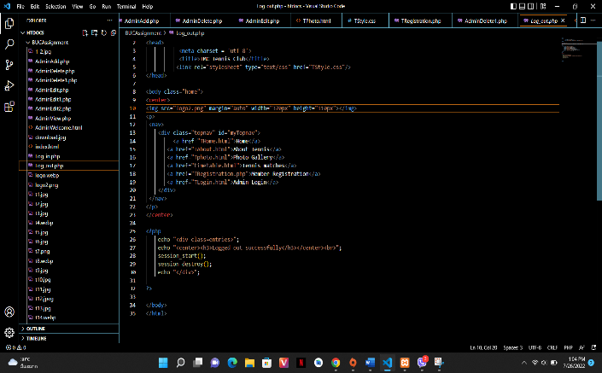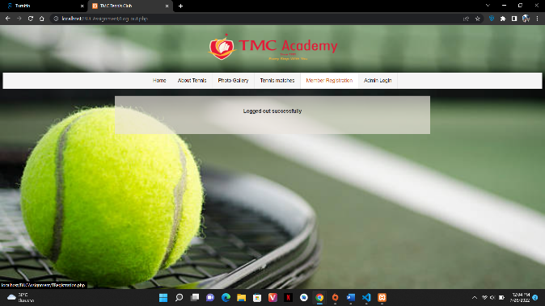 The final page for this website is logout page. If admin want to logout to home, about, photo, and so on. And coding for this page is simple as in the “Coding for logout”.

Logout page

Coding for logout

Site Map Design

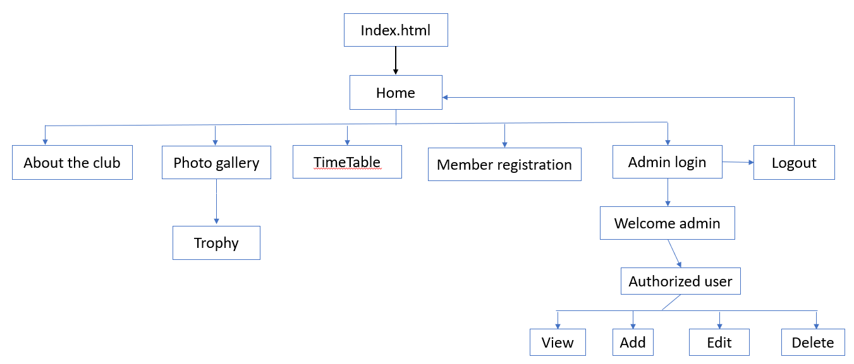

# **Conclusion**

This report is all details about the TMC Tennis club website with site map design. This report is with all coding screenshots and display output. Some of the coding is implicate from W3 school. (Anon., n.d.)

# References

Anon., n.d. *W3 school.* [Online]   
Available at: https://www.w3schools.com/  
[Accessed 26 july 2022].